**Closed Brayton Cycle with Supercritical CO2 Working Fluid**

**Ryan Konon, Nathan Stenseng**

**2021-03-21**

**Dr. Bryan Weber**

| **Nomenclature $\dot{W}$**  Power, kW $\dot{Q}$ Heat Rate, kW $\dot{m}$ Mass Flow Rate, kg/s $p$ Pressure, MPa $T$ Temperature, K $h$ Specific enthalpy, kJ/kg $s$ Specific entropy, kJ/kg/K $y$ Split Ratio  *Greek Symbols $η$*  Thermal Efficiency | *Subscripts $MC$*  Main Compressor $RC$ Recompressor $T$ Turbine $HTR$ High Temperature Recuperator $LTR$ Low Temperature Recuperator $net$ Net Power Output $in$ Input $out$ Output $cycle$ Cycle |
| --- | --- |

**Introduction:**

The ever increasing power consumption of civilization requires more power generation to keep up with demand. However with growing concerns about global climate change, we are realizing flaws in our old ways of power generation. We need power production techniques that are effective but minimize pollutant emissions. A closed Brayton cycle utilizing supercritical CO2 (S-CO2) as the working fluid is a step in the right direction, yielding a high cycle thermal efficiency while maintaining moderate turbine inlet temperatures [5].

The ideal Brayton cycle operates on four fundamental processes:

1. Adiabatic compression
2. Isobaric heat addition
3. Adiabatic expansion
4. Isobaric heat rejection

An S-CO2 Brayton cycle has a number of advantages over both helium and air Brayton cycles, as well as traditional Rankine Cycles. For starters, the S-CO2 Brayton cycle outperforms the water Rankine cycle, the air Brayton cycle, and the helium Brayton cycle for relatively low heat source temperatures, namely those ranging from 500°C to 900°C. This is because S-CO2 and other supercritical fluids have lower operating temperatures, thus broadening the selection of usable heat sources. Because of this, we can increase the cycle’s input heat and reduce its greenhouse gas emissions by utilizing more sustainable heat sources, such as waste nuclear heat and heat produced by renewables (sources that would fail to supply a sufficient heat transfer input for other working fluids). In conjunction with this, S-CO2 has a relatively low critical pressure (lower than water) and a high density. Therefore, the cycle can operate at lower pressures (thus requiring less compressor work) and use smaller equipment, saving space [1]. Finally, because S-CO2 has a critical temperature higher than ambient air, the heat sink in an S-CO2 Brayton cycle can use air instead of water. This limits the amount of fresh water used in industrial settings and saves this scarce resource [3].

Because of the improved thermal efficiency and environmental benefits, we will develop a 10-state S-CO2 Brayton cycle, independently analyzing how varying the main compressor inlet temperature, turbine inlet temperature, and split ratio will affect the net power output, the net heat transfer input, and the overall thermal efficiency.

**Methods:**

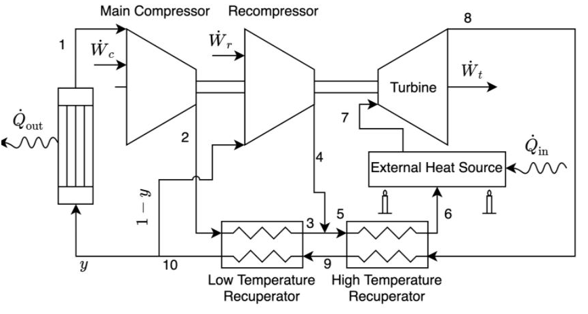

*Figure 1 depicts a schematic of our Recompression Brayton Cycle*

In this report, we will be studying a recompression Brayton Cycle, depicted in *Fig. 1*. A fraction of the working fluid starts by flowing through the main compressor and is then heated in the low temperature recuperator. Following this, it joins with the rest of the fluid which flowed through the recompressor. All the working fluid then travels through a high temperature recuperator, is heated, and flows through the main turbine. After this, the fluid traverses the high and low temperature recuperators, this time giving off heat before splitting to the main compressor and the recompressor. The main compressor stream is introduced to a precooler which removes heat from this fraction of the working fluid, and then the cycle repeats itself.

Each component in our system has a fixed thermal efficiency, defined in *Table 1A*. For turbines and compressors, we can use these thermal efficiencies to determine the amount of enthalpy the component adds or takes away from the working fluid:

$η_{MC}=\frac{h_{2s}-h_{1}}{h_{2}-h_{1}}$ eq.(1)

$η_{RC}=\frac{h_{4s}-h_{10}}{h_{4}-h_{10}}$ eq.(2)

$η_{T}=\frac{h_{8}-h_{7}}{h_{8s}-h_{7}}$ eq.(3)

Where $h_{2s}=h(p_{2},s_{1}), h_{4s}=h(p_{4},s_{10}),$ and $h_{8s}=h(p_{8},s_{7}).$ Since we model the turbine expansion and compressor compression as adiabatic, we can say that the change in enthalpy equates to the work done by the respective component:

${\dot{W}}_{MC}=\dot{m}y(h_{1}-h_{2})$ eq.(4)

${\dot{W}}_{RC}=\dot{m}(1-y)(h_{10}-h_{4})$ eq.(5)

${\dot{W}}_{T}=\dot{m}(h_{7}-h_{8})$ eq.(6)

${\dot{W}}_{net}={\dot{W}}_{MC}+{\dot{W}}_{RC}+{\dot{W}}_{T}$ eq.(7)

Assuming no stray heat transfer, we can also define the enthalpy transfer through the recuperators in terms of their efficiencies:

$η_{HTR}=\frac{h_{6}-h_{5}}{h_{8}-h_{9'}}$ eq.(8)

$η_{LTR}=\frac{h_{3}-h_{2}}{h_{9}-h_{10'}}$ eq.(9)

Where $h_{9}'=h(p_{9},T_{5})$ and $h_{10}'=h(p_{10},T_{2}).$

Two other needed parameters are the heat transfer input and output of the system. This is because we want to know how changing the temperature at the compressor and turbine inlet affects the cycle, and these temperatures are directly related to the heat addition and rejection:

${\dot{Q}}_{in}=\dot{m}(h_{7}-h_{6})$ eq.(10)

${\dot{Q}}_{out}=\dot{m}y(h_{1}-h_{10})$ eq.(11)

And finally, in order to measure the performance of our cycle, we will look at it’s overall thermal efficiency, defined by:

$η_{}=\frac{{\dot{W}}_{net}}{{\dot{Q}}_{in}}$ eq.(12)

**Results and Discussion:**

For our design of a closed S-CO2 Brayton Cycle, we have the following component efficiency constraints and initial state conditions:

| **Component** | **Efficiency** |  |  |  |  |
| --- | --- | --- | --- | --- | --- |
| Main Compressor | $η_{MC}=82\%$ |  | **State** | **Pressure (MPa)** | **Temperature (K)** |
| Recompressor | $η_{RC}=78\%$ |  | **1** | 8.25 | 315 |
| Turbine | $η_{T}=93\%$ |  | **5** | --- | 456.35 |
| High Temperature Recuperator | $η_{HTR}=95\%$ |  | **7** | 22 | 750 |
| Low Temperature Recuperator | $η_{LTR}=89\%$ |  |  |  |  |

*Table 1A (Left) and 1B (Right) are our given design conditions*

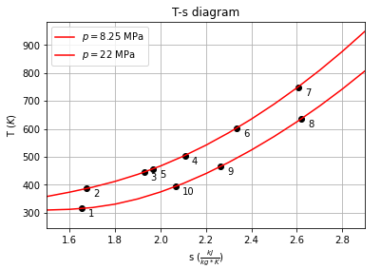

*Figure 2 depicts the T-s diagram according to our initial design parameters.*

Using the information in *Tables 1A*, *Table 1B,* and Thermostate, we can set all 10 states (*Fig 2)* using the equations defined in the methods section [2]. Assuming a typical mass flow rate of 50 kg/s, or equivalently 180,000 kg/hr, our Brayton cycle achieves a net power output of 3.35 MW (eq. 7), requiring a heat transfer input of 9.08 MW (eq. 10), and thus producing an overall thermal efficiency of 36.88% (eq. 11) [6]. Given the system is not yet optimized at the initial state conditions, this thermal efficiency is relatively good, already exceeding today's standard efficiency levels of around 34% [1]. Likewise, we can do better by optimizing the cycle’s main compressor inlet temperature, turbine inlet temperature, and split ratio. 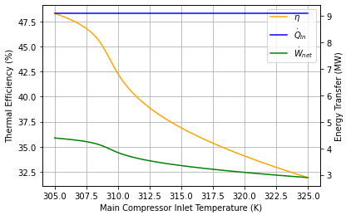

*Figure 3 depicts the overall cycle thermal efficiency, net power output, and heat transfer input over varying inlet temperatures for the main compressor.*

It is known that a lower compressor inlet temperature is optimal, as a cooler fluid is more dense and thus requires less work to be compressed from $p_{1}$ to $p_{2}$. *Fig 3* validates this statement. But realistically, lowering the main compressor inlet temperature requires an increase in the mass flowing of coolant through our heatsink, which cannot be done indefinitely. From *Fig 3,* we can see that as the inlet temperature decreases, thermal efficiency increases. However, the thermal efficiency increases more gradually when dropping below 307.5 K. Thus, for our design, we recommend changing the main compressor inlet temperature from 315 K to 307.5 K. Lowering the temperature any more is not worth the corresponding increase in mass flow rate of coolant (which is air in our design). Alone, this optimization increases the net power output to 4.25 MW and bumps the thermal efficiency up to 46.82% (nearly a 10% increase compared to the initial design parameters), while maintaining a necessary heat transfer input of 9.08 MW.

*Figure 4A (Left) depicts how our system is affected by varying turbine inlet temperatures. Figure 4B(Right) depicts the rate at which the thermal efficiency of our cycle increases with increasing turbine inlet temperatures.*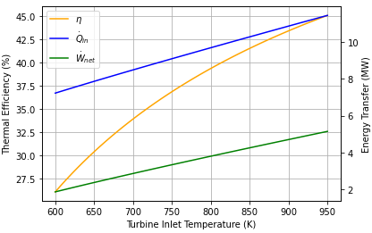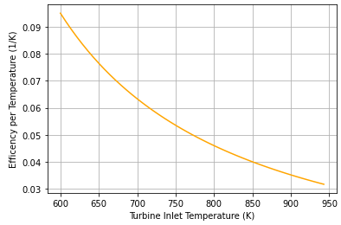

*Fig 4A* shows a similar trend as *Fig 3.* That is, we want to increase the turbine inlet temperature as much as possible, given the turbine inlet temperature is directly proportional to the thermal efficiency. However, *Fig 4B* demonstrates that as the turbine inlet temperature increases, the corresponding increase in thermal efficiency slows. Namely, beyond 850 K, the increase in efficiency does not justify the harder to reach turbine inlet temperature. A critical advantage of an S-CO2 Brayton cycle is its ability to outperform other, similar cycles, at lower temperatures. This is important because it allows us to utilize more sustainable heat sources. We therefore recommend an inlet temperature of 850 K. This is ideal because solar concentrating plants, on average, achieve temperatures around 900 K making them the perfect source of heat transfer input for our plant [4]. And to make our design less reliant on the sun, we could couple it with a nuclear power plant, repurposing the waste nuclear heat as an additional heat source [5]. Independently, this optimization increases the net work output to 4.26 MW and the thermal efficiency to 41.55%, but requires 10.26 MW of heat transfer input.

Our final optimization involves varying the mass split ratio between 0.4 and 0.9. While lower mass split ratios result in less heat transfer output, we can see from *Fig 5* a positive, directly proportional relationship between the mass split ratio and the thermal efficiency. We therefore chose a ratio of 0.9 to maximize thermal efficiency. Changing only this ratio, the net power increases to 3.58 MW, the thermal efficiency increases to 39.46%, and the heat transfer input remains at 9.08 MW.

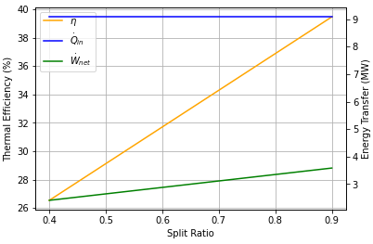

*Figure 5 depicts the the effect of the mass split ratio on the overall cycle thermal efficiency, the power output, and the heat transfer input*

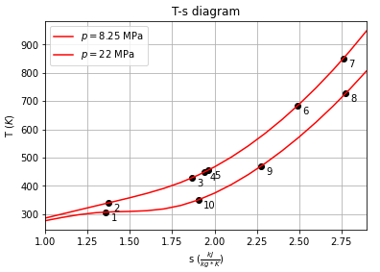

*Figure 6 is the T-s diagram of our system if all recommendations are taken into account.*

Coupling all three optimizations changes the T-s diagram, as shown in *Fig 6*. The system now achieves a net power output of 5.39 MW and a thermal efficiency of 52.57%, while demanding a heat transfer input of 10.26 MW. In other words, these recommended design conditions will produce 60.9% more power and be 42.54% more thermally efficient for only a 13% increase in heat transfer input (compared with the initial design parameters). *Table 2* summarizes the individual and coupled effects of our optimizations on the cycle’s performance.

| Optimization | None (Initial Design) | Main Compressor Inlet Temp. | Turbine Inlet Temp. | Split Ratio | All |
| --- | --- | --- | --- | --- | --- |
| Thermal Efficiency (%) | 36.88  ---  --- | 46.82  9.94  26.95 | 41.55  4.76  12.66 | 39.46  2.58  7.00 | 52.57  15.69  42.54 |
| Power Output (MW) | 3.35  ---  --- | 4.25  0.9  26.87 | 4.26  0.91  27.16 | 3.58  0.23  6.87 | 5.39  2.04  60.90 |
| Heat Transfer Input (MW) | 9.08  ---  --- | 9.08  0.0  0.0 | 10.26  1.18  12.04 | 9.08  0.0  0.0 | 10.26  1.18  13.00 |

*Table 2 presents the individual and coupled effects of our optimizations on the relevant cycle performance metrics. Note, from top to bottom, the first number represents the actual value for a given metric, the second represents the raw difference from the initial design conditions, and the third represents the percent difference from the initial design conditions.*

**Conclusion:**

We have designed and optimized an S-CO2 Brayton cycle that operates with a 52.57% thermal efficiency, produces a net power output of 5.39 MW, and requires a heat transfer input of 10.26 MW. To achieve this performance, we recommend that the client changes the main compressor inlet temperature to 307.5 K, the turbine inlet temperature to 850 K, and the split ratio to 0.9. Compared to more traditional power generation cycles, our design offers numerous benefits. Namely, it yields a higher thermal efficiency at a moderate turbine inlet temperature (enabling a wide range of heat sources to be used), it takes up less space (minimizing capital costs), and it utilizes an abundant working fluid [3]. With that being said, there are drawbacks to every power generation cycle. Production of small components for the system, that are appropriately pressure and temperature rated, is a material science challenge [7]. The small parts and more complex cycle also make maintenance difficult. Both of these factors make the cycle harder to employ on a large scale. Regardless of these drawbacks, the S-CO2 Brayton Cycle designed in this paper exceeds today's standards in terms of efficiency and versatile power generation.

**References:**

1. Yaping Liu, Ying Wang, Diangui Huang, Supercritical CO2 Brayton cycle: A state-of-the-art review, Energy, Volume 189, 2019, 115900, ISSN 0360-5442, <https://doi.org/10.1016/j.energy.2019.115900>. (<https://www.sciencedirect.com/science/article/pii/S0360544219315786>)
2. B. Weber, “Thermostate: A state manager for thermodynamics courses,” University of Connecticut, 2018, <https://github.com/bryanwweber/thermostate/>
3. White, Charles. 2015 QTR Ch. 4 Technology Assessment: Supercritical Carbon Dioxide Brayton Cycle. United States: N. p., 2016. Web.
4. W.-D. Steinmann, 21 - Thermal energy storage systems for concentrating solar power (CSP) technology, Editor(s): Luisa F. Cabeza, In Woodhead Publishing Series in Energy, Advances in Thermal Energy Storage Systems, Woodhead Publishing, 2015, Pages 511-531, ISBN 9781782420880, <https://doi.org/10.1533/9781782420965.4.511>. (<https://www.sciencedirect.com/science/article/pii/B9781782420880500213>)
5. “Nuclear Process Heat for Industry.” *Nuclear Process Heat - World Nuclear Association*, www.world-nuclear.org/information-library/non-power-nuclear-applications/industry/nuclear-process-heat-for-industry.aspx#:~:text=The%20potential%20application%20of%20nuclear,to%20hydrogen%20production%20opens%20up.
6. Zhou, Aozheng & Li, Xue-song & Ren, Xiao-dong & Song, Jian & Gu, Chun-wei, 2020. "Thermodynamic and economic analysis of a supercritical carbon dioxide (S–CO2) recompression cycle with the radial-inflow turbine efficiency prediction," Energy, Elsevier, vol. 191(C).
7. Conboy, T., Wright, S., Pasch, J., Fleming, D., Rochau, G., and Fuller, R. (September 28, 2012). "Performance Characteristics of an Operating Supercritical CO2 Brayton Cycle." ASME. J. Eng. Gas Turbines Power. November 2012; 134(11): 111703. <https://doi.org/10.1115/1.4007199>